EDGE INTELLIGENCE LABORATORY
ASSIGNMENT 8

SUBMITTED BY
SHIBU P
25MML0042

Table of Contents
S.No | Description | Page No
1 | Live Video Checking from laptop camera | 3
2 | Capturing live video from the camera | 4-5
3 | Loading sample video from Local device | 6-7
4 | Analyzing the sample offline video’s Grayscale, RGB, Negative | 8-10
5 | Loading Offline sample video and printing total frames of a video,fps,width and height of the frame. | 11
6 | Loading video and converting into Grayscale video | 12
7 | Creating Rectangle and circle using opencv | 13-14
8 | Converting live video to find edge using canny operator | 15-19
9 | Converting Live video to Negative video: | 20-21
10 | Detecting the motion if motion found edge will be shown otherwise black screen will be shown. | 22-24
11 | Number Plate Detection System | 25-36

On Device Image Recognition
Code Link
1.Importing Libraries and Checking live video from laptop camera
cap = cv2.VideoCapture(0, cv2.CAP_DSHOW)
cv2.VideoCapture() is a method
0 is used here for default inbuilt camera
cv2.CAP_DSHOW is used for direct show backend for windows
cap.isOpened() is used to check whether camera works. if works then it returns true otherwise it returns false.
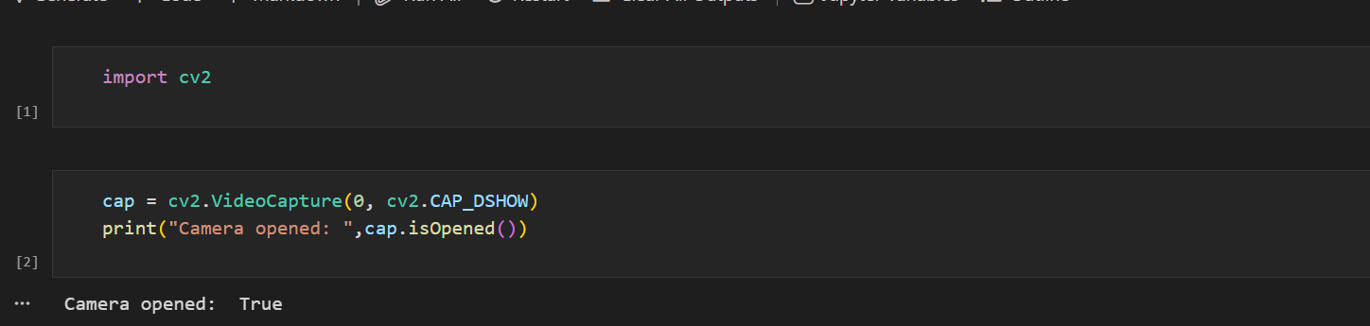

2.Capturing video from Laptop camera
A while True loop is then used to continuously read frames from the camera. Inside the loop, ret, frame = cap.read() captures a single frame, here ret is a Boolean value indicating whether the frame was successfully captured, and frame contains the actual image data of the captured frame. cv2.imshow("laptop camera", frame) displays the video frame in a window titled “laptop camera.” The function cv2.waitKey(1) waits for 1 millisecond for a keyboard input, and the condition & 0xFF == ord('q') checks whether the user pressed the 'q' key. If 'q' is pressed, the loop breaks and the video capture stops. Thus, the program continuously reads and displays frames from the webcam until the user presses the 'q' key to exit.
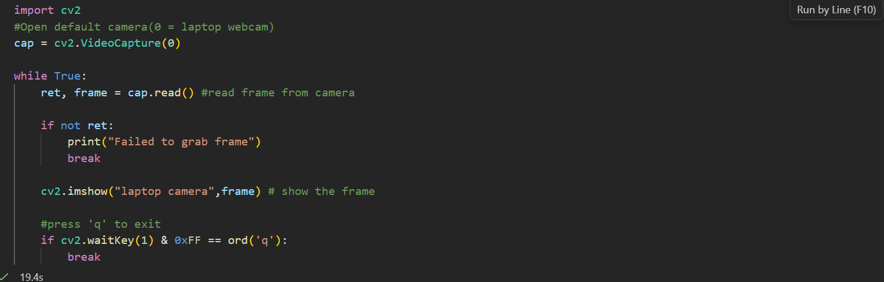
Output:
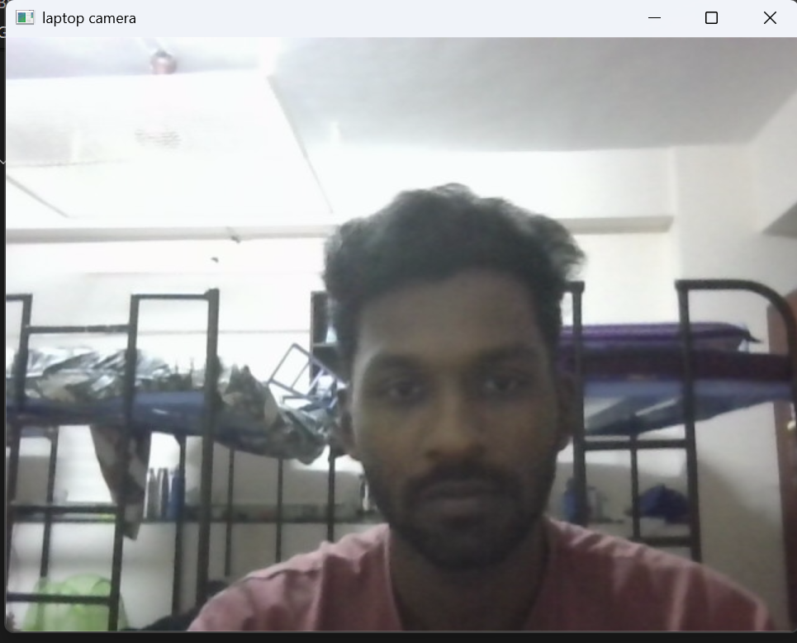

3.Loading sample video from local device:
Instead of VideoCapture parameter as 0 we pass the path of the offline local video.

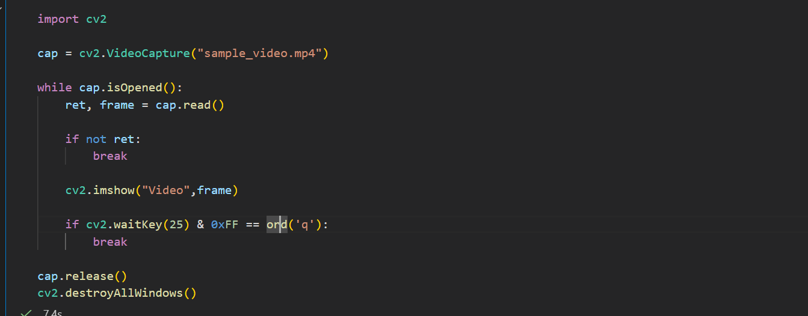

Output:
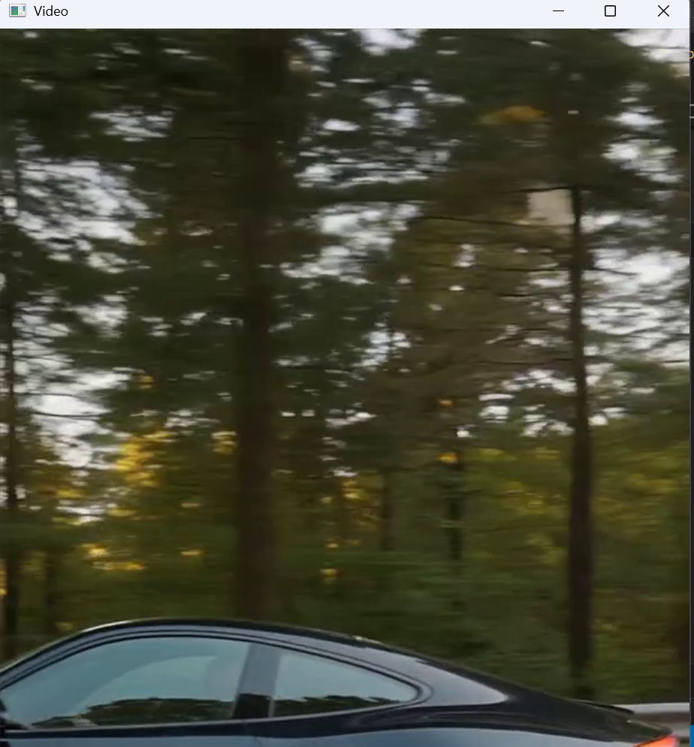

4.Analyzing the sample offline video’s Grayscale, RGB, Negative
cv2.cvtColor(frame, cv2.COLOR_BGR2GRAY) converts the frame into a grayscale image, cv2.cvtColor(frame, cv2.COLOR_BGR2RGB) converts the OpenCV BGR format to RGB for proper display in Matplotlib. negative = 255 – frame, convert image to negative.h, w, c = frame.shape extract the height ,width and channel of the image

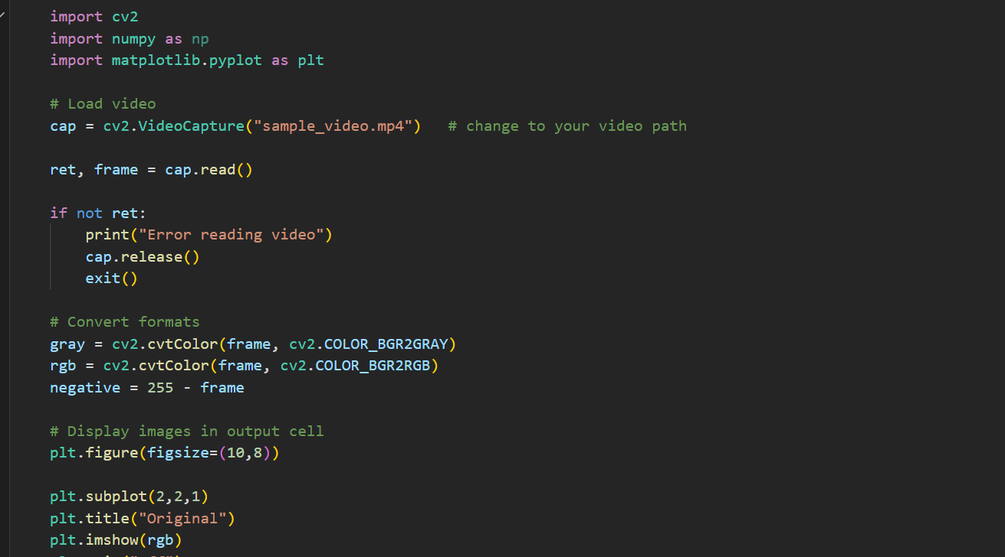

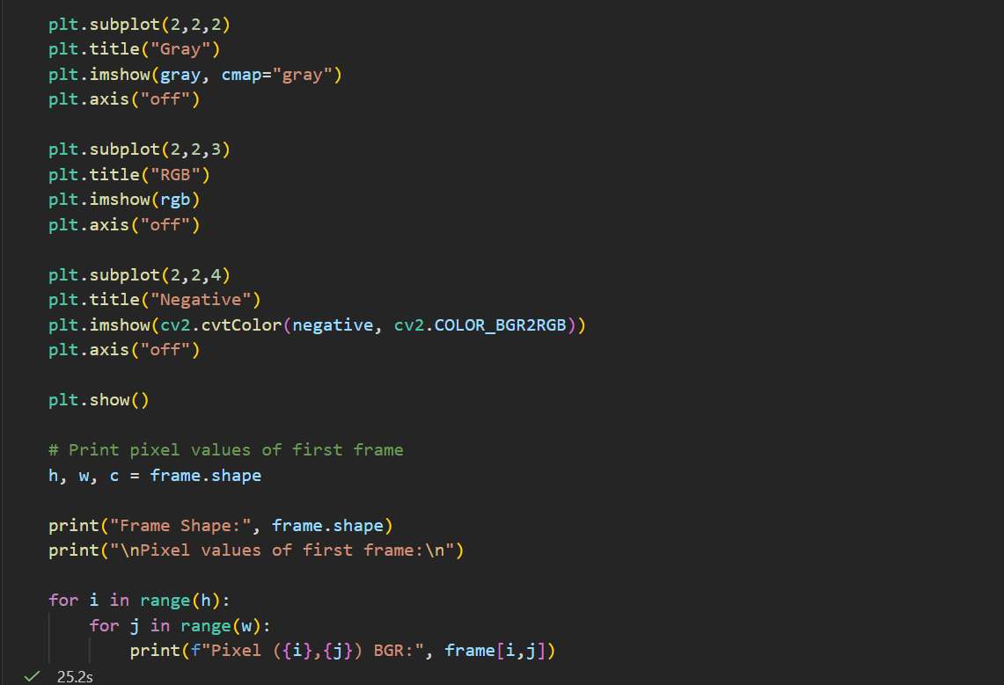

Output:
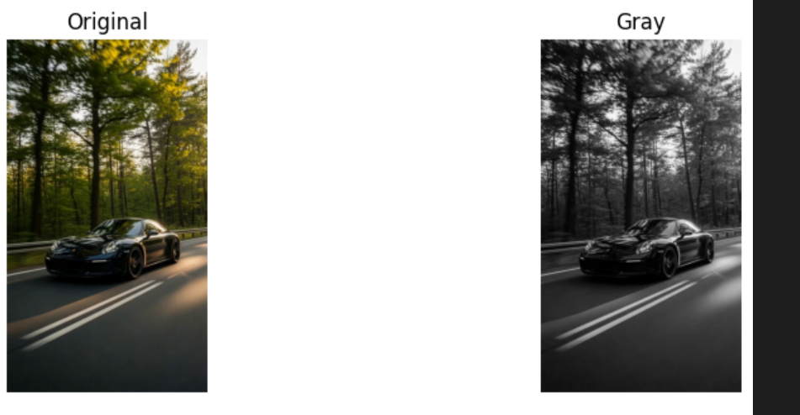

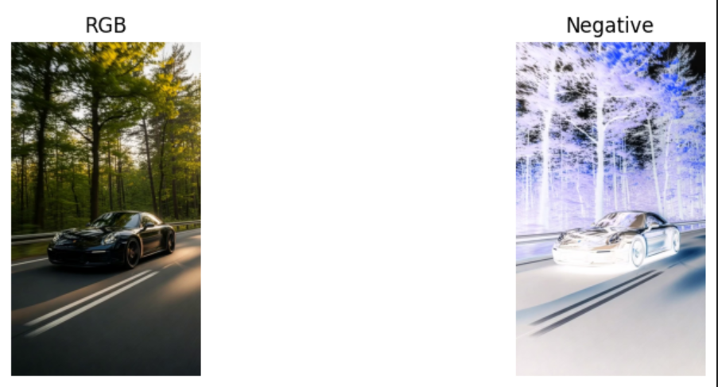

Showing pixel values:
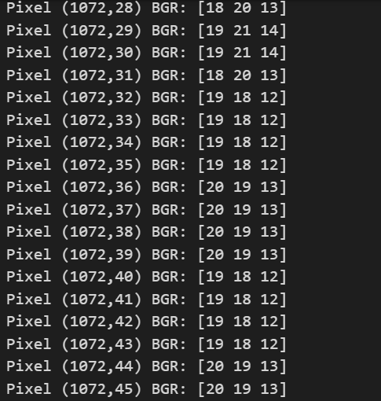
5.Loading Offline sample video and printing total frames of a video,fps,width and height of the frame.
total_frames = int(cap.get(cv2.CAP_PROP_FRAME_COUNT)) obtains the total number of frames present in the video
fps = cap.get(cv2.CAP_PROP_FPS), retrieves the frames per second (FPS) of the video, which indicates how many frames are displayed every second during playback.
The third line, width = cap.get(cv2.CAP_PROP_FRAME_WIDTH), returns the width of each video frame in pixels, while the fourth line
height = cap.get(cv2.CAP_PROP_FRAME_HEIGHT), returns the height of each frame in pixels.

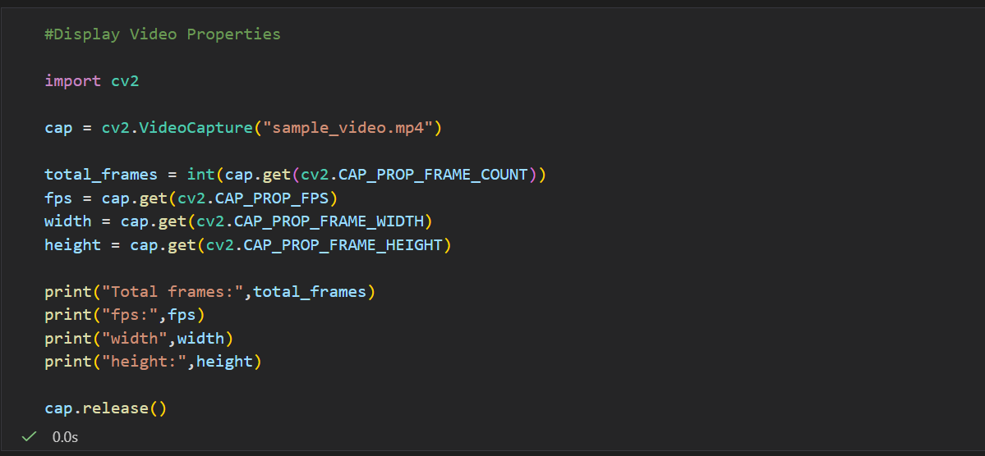

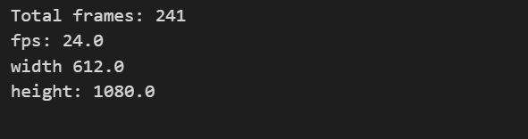

6.Loading video and converting into Grayscale video:

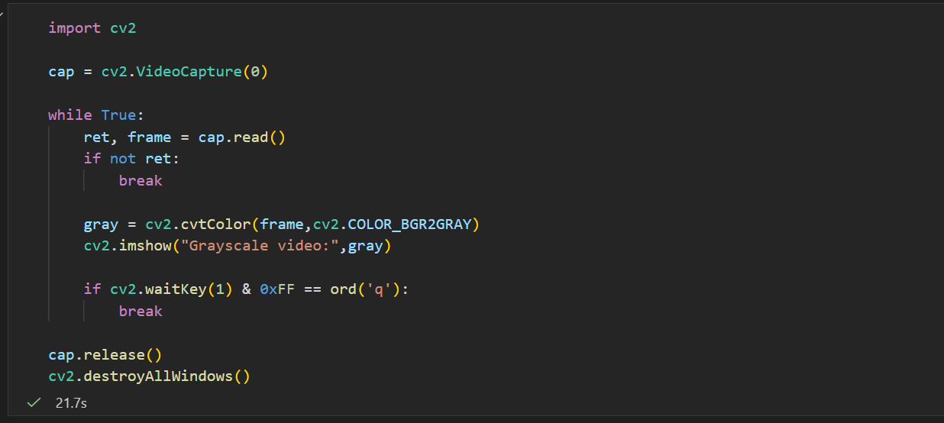

Output:
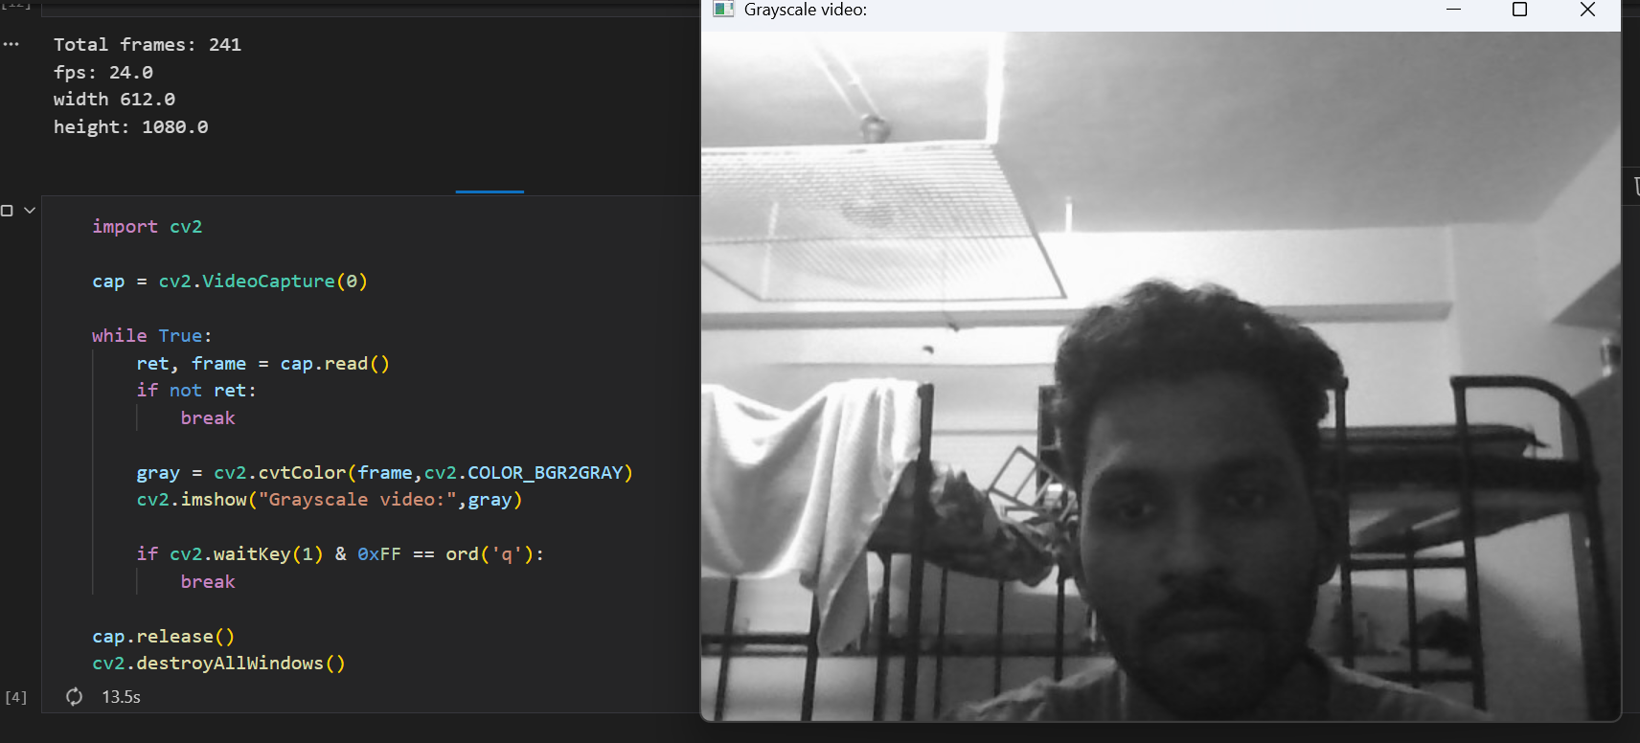

7.Creating Rectangle and circle using opencv
cv2.rectangle(frame, (100,100), (300,300), (0,255,0), 3), draws a rectangle on the image stored in frame. The point (100,100) represents the top-left corner of the rectangle and (300,300) represents the bottom-right corner. 3 specifies the thickness of the rectangle border in pixels. The cv2.circle(frame, (200,200), 50, (255,0,0), 3), draws a circle on the frame where (200,200) is the center of the circle, 50 is the radius, (255,0,0) represents blue color in BGR format, and 3 indicates the thickness of the circle’s outline. The cv2.putText(frame, "OpenCV practice", (50,50), cv2.FONT_HERSHEY_SIMPLEX, 1, (0,0,255), 2) to display text on the image. Here "OpenCV practice" is the text string, (50,50) is the starting position of the text on the image, cv2.FONT_HERSHEY_SIMPLEX specifies the font style, 1 represents the font scale (size), (0,0,255) is the red color in BGR format, and 2 indicates the thickness of the text strokes.
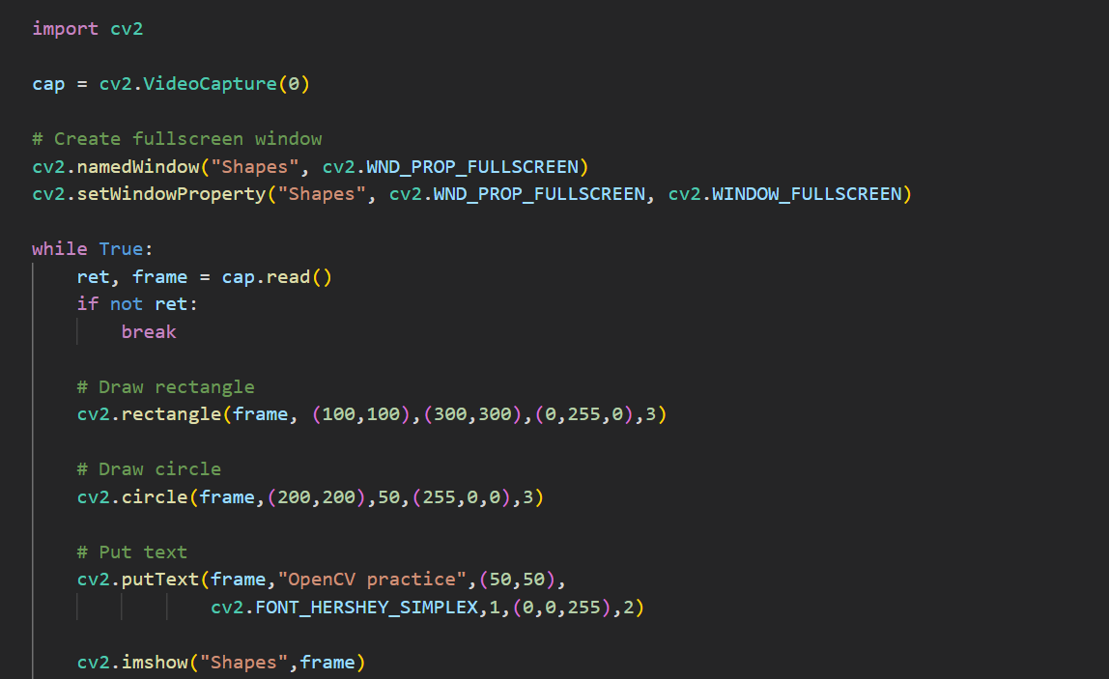

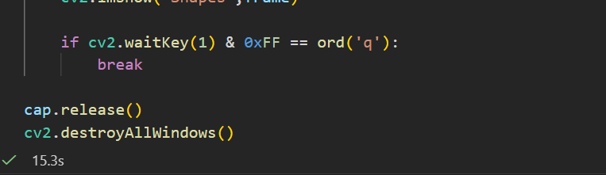

Output:
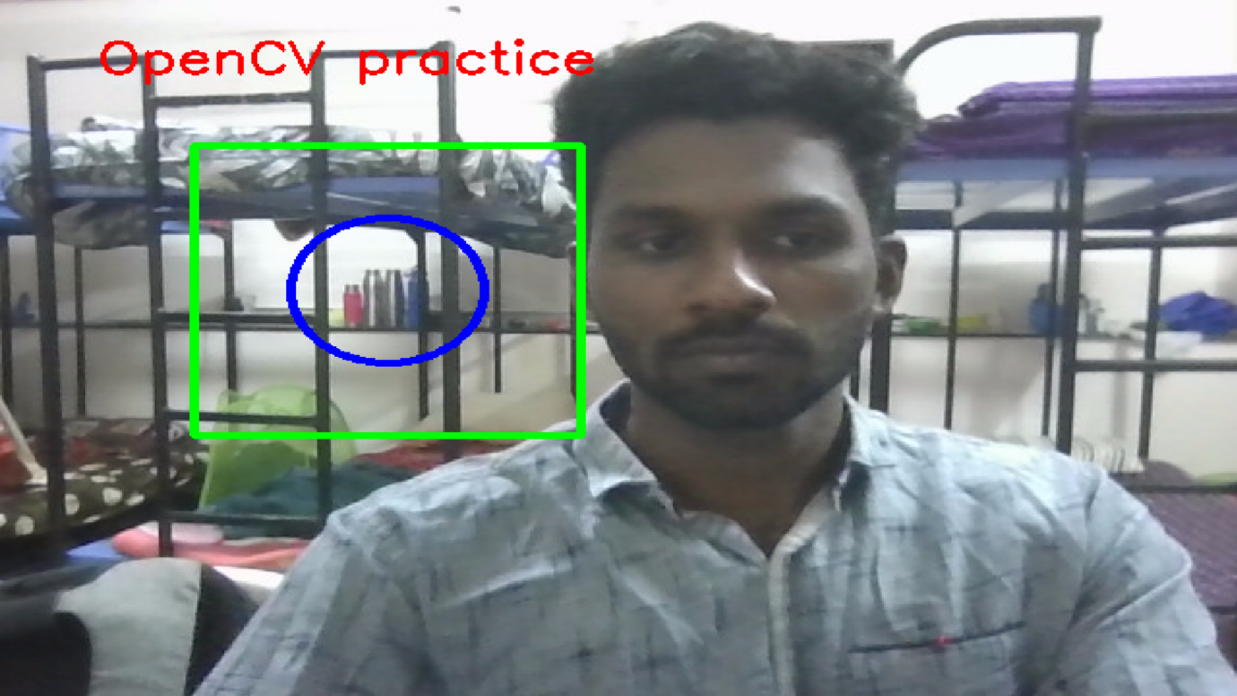

8.Converting live video to find edge using canny operator:

Mathematical Equation:
Step 1: Convert Image to Grayscale
$Gray = 0.299R + 0.587G + 0.114B$
Gray = Intensity value of the grayscale image

R = Red channel intensity value
G = Green channel intensity value
B = Blue channel intensity value
0.299 = Weight of the red component in grayscale conversion
0.587 = Weight of the green component in grayscale conversion
0.114 = Weight of the blue component in grayscale conversion

Step 2: Noise Reduction (Gaussian Blur)
$G\left(x,y\right)=\frac{1}{2πσ^{2}}e^{-\frac{x^{2}+y^{2}}{2σ^{2}}}$
G(x,y) : Gaussian function value at pixel location (x,y)
x : Horizontal distance from the center of the kernel
y : Vertical distance from the center of the kernel
σ : Standard deviation controlling the amount of smoothing
π : Mathematical constant (≈ 3.14159)
e : Euler's number (≈ 2.71828)
Step 3:The image is convolved with the Gaussian kernel:
$I_{s}\left(x,y\right)=I\left(x,y\right)*G\left(x,y\right)$
I_s(x,y) = Smoothed image intensity at pixel location (x,y)
I(x,y) = Original image intensity at pixel location (x,y)
G(x,y) = Gaussian kernel (Gaussian function)
* = Convolution operation
x = Horizontal pixel coordinate
y = Vertical pixel coordinate

Step 4: Compute Image Gradient it finds $G_{x}andG_{y}$
The gradients in the x-direction and y-direction are computed using Sobel operators.
• $G_{x}$= Gradient in the horizontal direction
$G_{y}$= Gradient in the vertical direction

Step 5: Gradient Magnitude (Edge Strength)
$G=\left|G_{x}\right|+\left|G_{y}\right|$
G = Gradient magnitude (overall edge strength)
G_x = Gradient in the horizontal (x) direction
G_y = Gradient in the vertical (y) direction
|G_x| = Absolute value of the horizontal gradient
|G_y| = Absolute value of the vertical gradient

Step 6: Gradient Direction (Edge Orientation)
$θ=\tan^{-1}\left(\frac{G_{y}}{G_{x}}\right)$
θ = Gradient direction (edge orientation)
G_x = Gradient in the horizontal (x) direction
G_y = Gradient in the vertical (y) direction
tan⁻¹ = Inverse tangent function used to compute the angle of the gradient

$G\left(x,y\right)>T_{H}$ - If the gradient magnitude at pixel $\left(x , y\right)$is greater than the high threshold $T_{H}$, the pixel is considered a strong edge.

$T_{L}<G\left(x,y\right)<T_{H}$ - If the gradient magnitude lies between the low threshold $T_{L}$and high threshold $T_{H}$, the pixel is considered a weak edge.

$G\left(x,y\right)<T_{L}$ - If the gradient magnitude is less than the low threshold $T_{L}$, the pixel is considered noise or non-edge and is removed.

Step 7: Non-Maximum Suppression
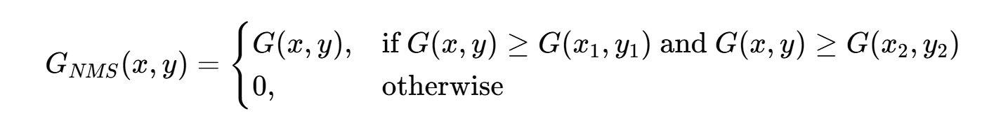
G(x,y) = Gradient magnitude at pixel location (x,y)
G(x₁,y₁) = Gradient magnitude of the neighboring pixel in the gradient direction
G(x₂,y₂) = Gradient magnitude of the neighboring pixel in the opposite gradient direction
G_NMS(x,y) = Gradient value after non-maximum suppression
(x,y) = Pixel coordinates in the image

Steps of Canny Edge Detection:
- Convert the image to grayscale – reduce the image from RGB to a single intensity channel.
- Apply Gaussian blur – smooth the image to remove noise.
- Calculate image gradients – find how quickly the intensity changes in horizontal and vertical directions.
- Compute gradient magnitude and direction – determine the strength and orientation of edges.
- Apply non-maximum suppression – thin the edges by keeping only the strongest pixels.
- Apply double thresholding – classify pixels as strong edges, weak edges, or non-edges.
- Perform edge tracking by hysteresis – keep weak edges that are connected to strong edges and remove the rest.

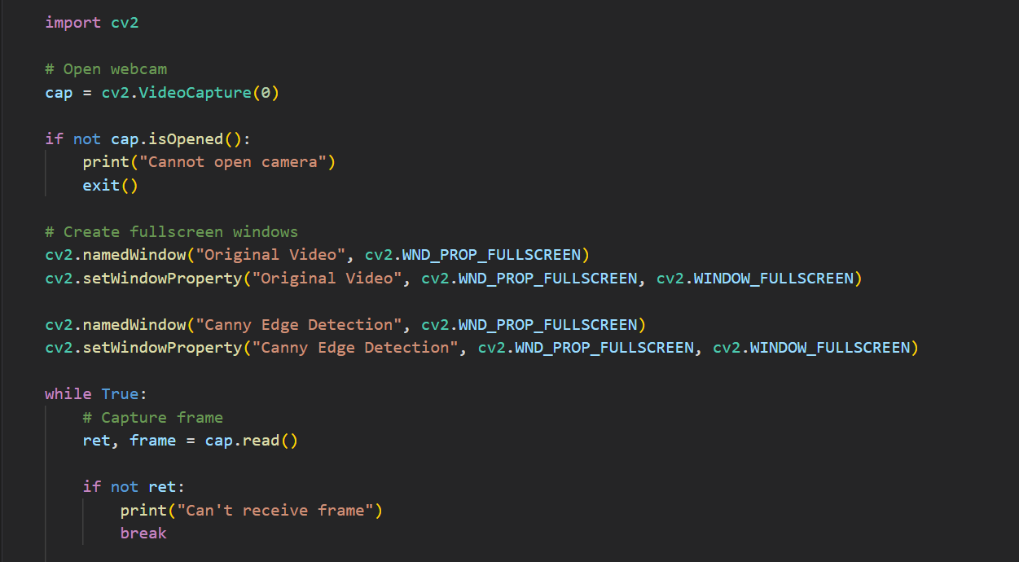
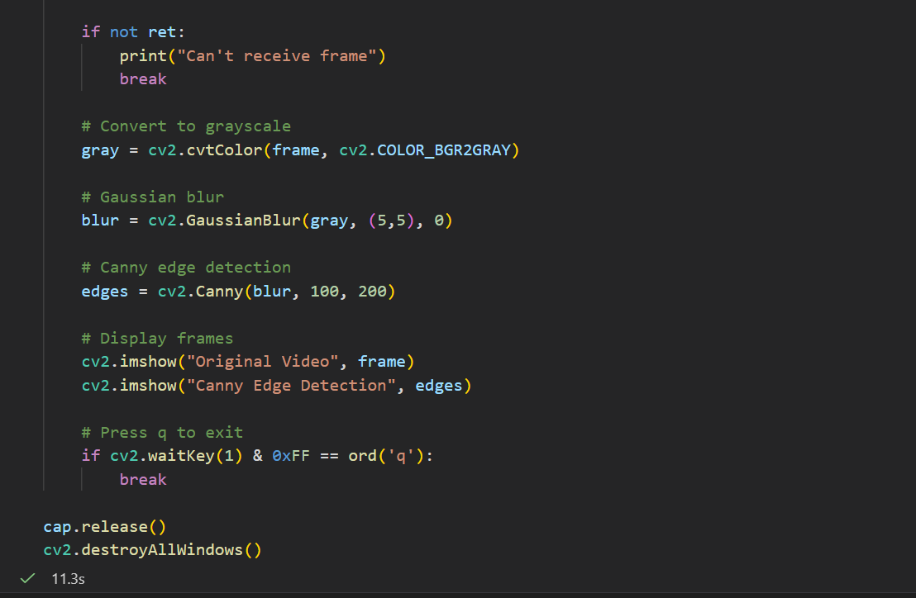

Output:
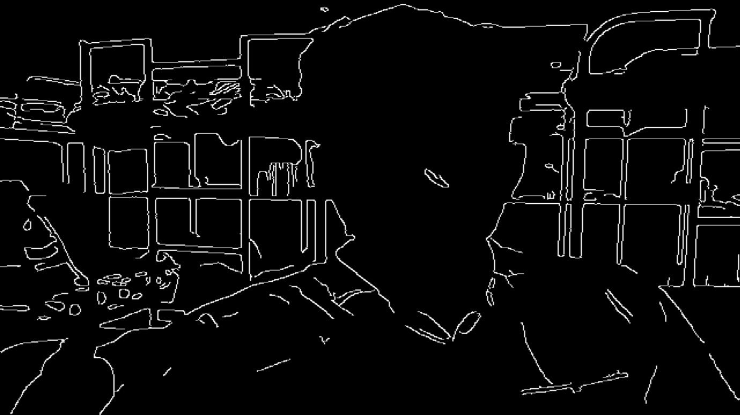

9.Converting Live video to Negative video:
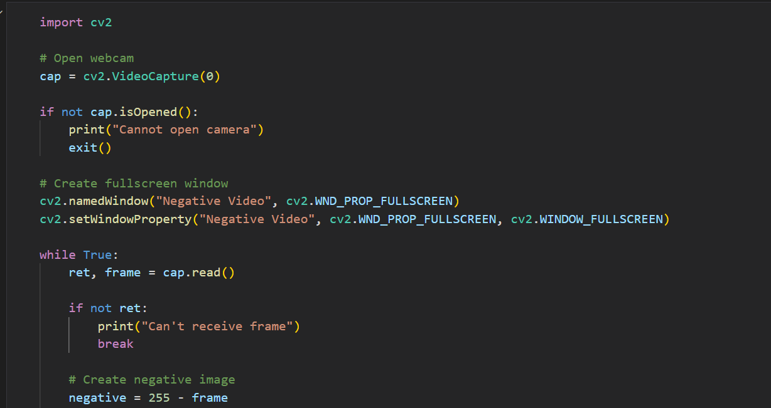

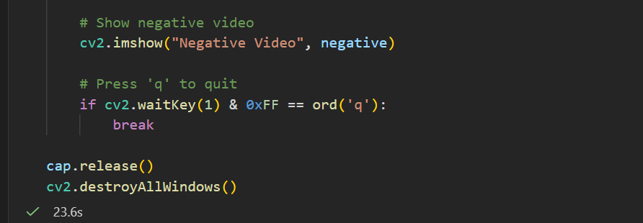
Output:
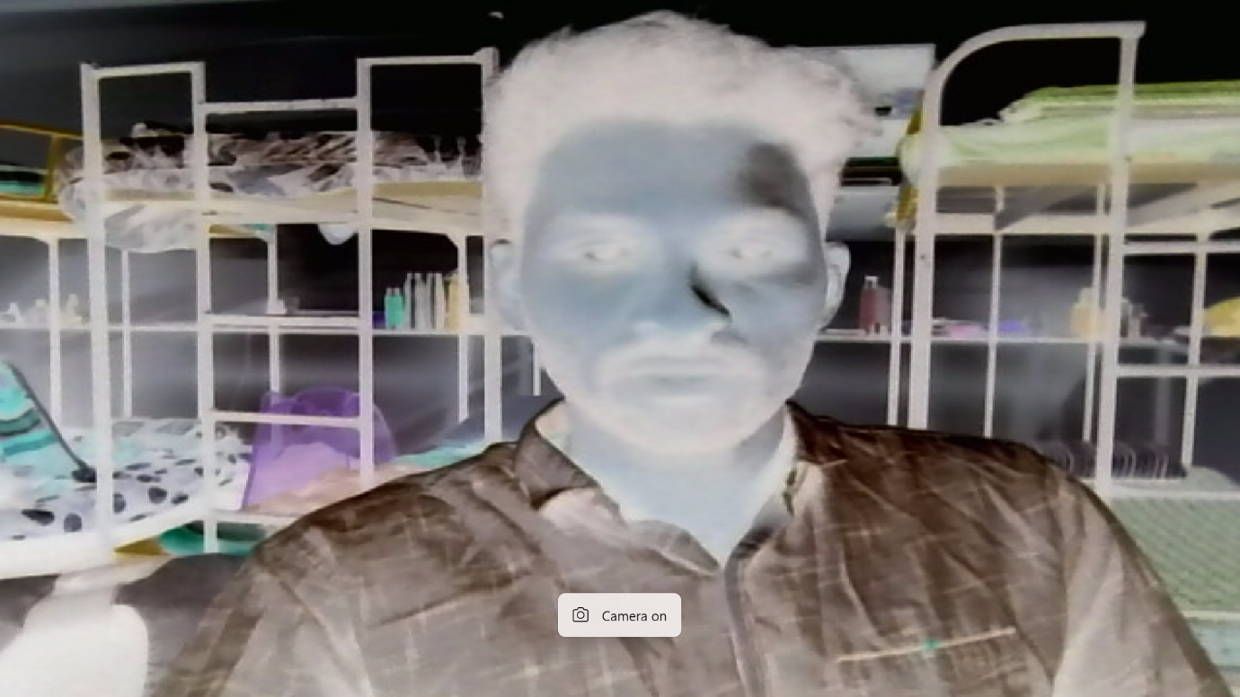
Mathematical Equation
For an 8-bit image:
$$s=255-r$$
Where:
- $r$= original pixel value
- $s$= negative pixel value
- 255 = maximum intensity value in an 8-bit image

10.Detecting the motion if motion found edge will be shown otherwise black screen will be shown.

Mathematical Equation:
1. Grayscale Conversion
$$Gray\left(x,y\right)=0.299R\left(x,y\right)+0.587G\left(x,y\right)+0.114B\left(x,y\right)$$
Gray(x,y) = Intensity value of the grayscale image at pixel location (x,y)
R(x,y) = Red channel intensity value at pixel location (x,y)
G(x,y) = Green channel intensity value at pixel location (x,y)
B(x,y) = Blue channel intensity value at pixel location (x,y)
(x,y) = Pixel coordinates in the image
2. Frame Difference (Motion Detection):
$D\left(x,y\right)=\left|G_{t}\left(x,y\right)-G_{t-1}\left(x,y\right)\right|$
D(x,y) = Difference value at pixel location (x,y)
$G_{t}$ (x,y) = Pixel intensity at position (x,y) in the current frame (time t)
$G_{t-1}$(x,y) = Pixel intensity at position (x,y) in the previous frame (time t−1)
| | = Absolute value operator
(x,y) = Pixel coordinates in the image

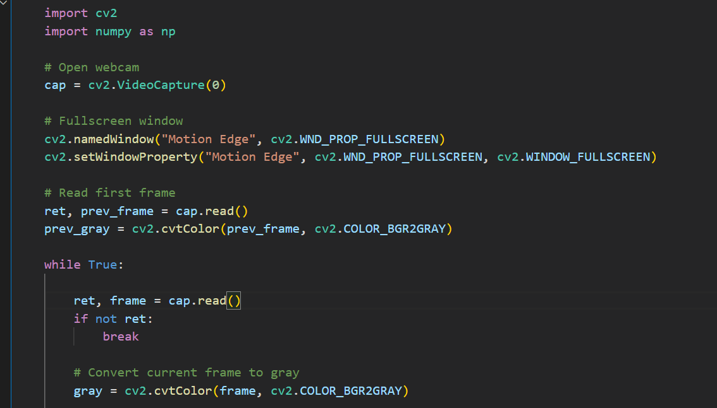

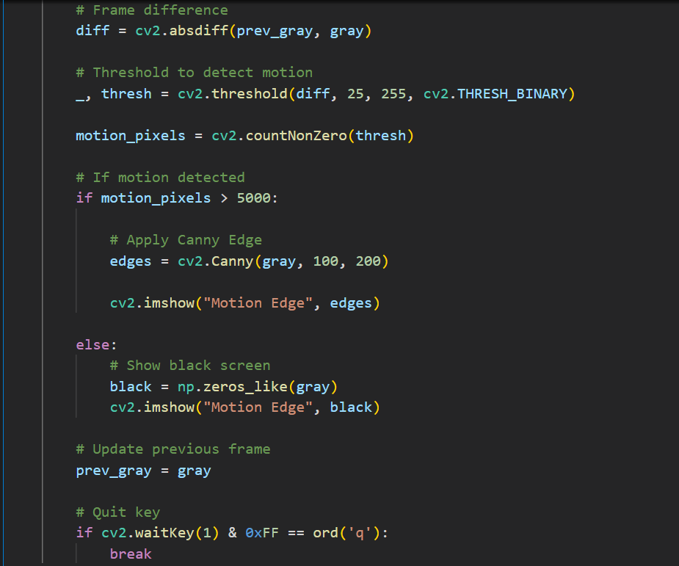

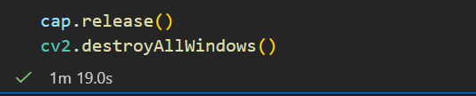

Output:
Drive Output

11. Number Plate Detection System

Abstract
This report details the development and implementation of a backend microservice designed to facilitate and manage remote file operations via the File Transfer Protocol (FTP). Built on the Spring Boot framework, the system exposes RESTful APIs for file uploading, image retrieval, and dynamic folder archiving, all while maintaining a persistent, database-backed audit trail. The system integrates a machine learning model and OCR engine to detect and extract vehicle number plate text from uploaded images in real time.

1. System Architecture and Technologies
The application follows a multi-layered architecture that clearly separates the web controller, business logic, and data access layers. This separation ensures maintainability, scalability, and ease of testing across all components.
- Backend Framework: Spring Boot (Java) provides the core infrastructure, REST API handling, dependency injection, and automatic multithreading support.
- Database & ORM: PostgreSQL is used as the relational database, integrated via Spring Data JPA and Hibernate. Hibernate's schema auto-generation (ddl-auto=update) initializes the database tables automatically on startup.
- FTP Integration: The Apache Commons Net library (FTPClient) powers low-level communication with the remote FTP server, enabling file uploads, directory navigation, and binary file writes.
- ML & OCR: A machine learning model detects the number plate region in the image, and an OCR engine extracts the alphanumeric characters from that region.

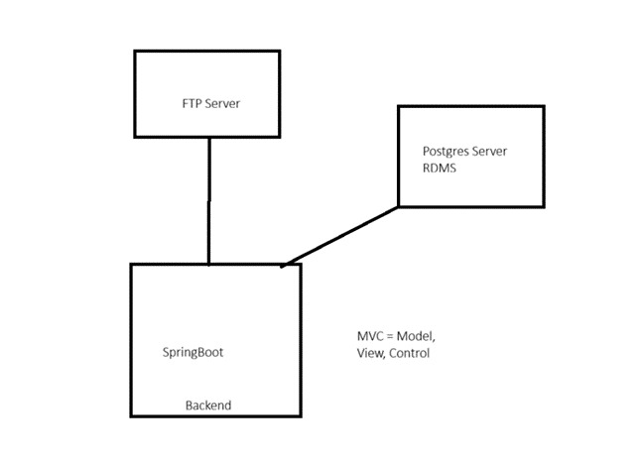
Figure 1: System Architecture — SpringBoot, FTP Server, and PostgreSQL

2. System Workflow — Flow Diagram

Step 1 | Frontend / Camera | User captures vehicle image and sends it via POST /api/ftp/detect
↓
Step 2 | API Controller (Spring Boot) | Validates file format, file size, and request headers (X-Ftp-Path)
↓
Step 3 | Service Layer | Business logic: metadata generation, FTP/DB health checks
↓
Step 4 | FTP Server (IIS / Windows) | Smart directory creation; stores uploaded image centrally
↓
Step 5 | ML Detection Model | Detects number plate region; overlays bounding box on output image
↓
Step 6 | OCR Engine | Extracts alphanumeric text from the detected number plate region
↓
Step 7 | PostgreSQL Database | Stores FileAuditLog: filename, remote path, upload timestamp
↓
Step 8 | Response to Client | Returns JSON: { "plate_number": "KL07AB1234", "status": "success" }

3. Windows Server Infrastructure Setup
To support the backend microservice, a local FTP environment was configured using Internet Information Services (IIS) on a Windows operating system. The following steps were carried out to set up the FTP server:
- The core FTP Server role and FTP Extensibility were enabled within Windows Features.
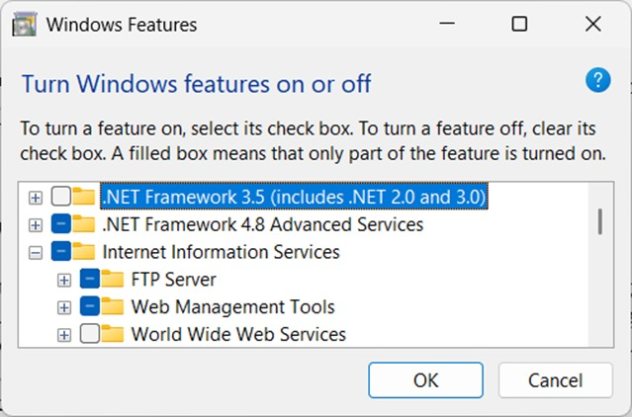
Figure 2: Enabling FTP Server role under Internet Information Services in Windows Features
- A new FTP site named EdgeFTP was provisioned in IIS Manager, bound to the standard port 21, configured to use Basic Authentication, with physical path set to D:\FTP shared.
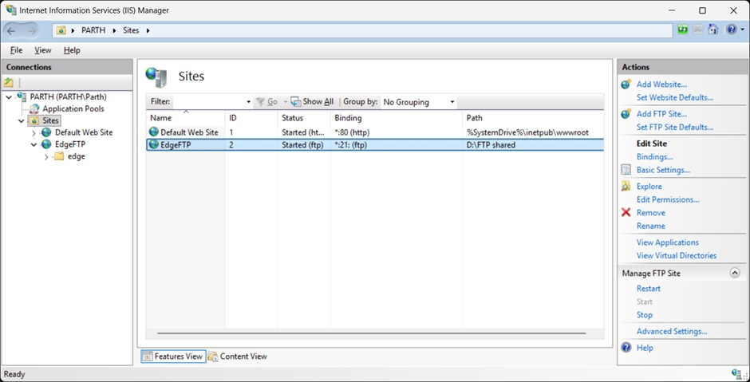
Figure 3: IIS Manager showing the EdgeFTP site running on port 21
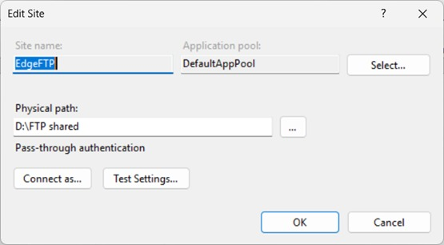
Figure 4: Edit Site dialog — EdgeFTP site configuration with physical path D:\FTP shared
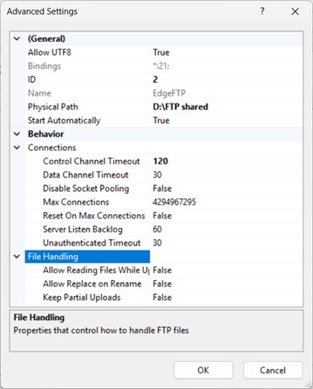
Figure 5: FTP Advanced Settings — connection timeouts and file handling properties
- Because IIS FTP relies on native Windows system accounts, a dedicated local user account was created specifically for this service via the Windows Command Prompt.
- An FTP Authorization Rule was added in IIS Manager to grant the new user explicit Read and Write permissions.
- Windows NTFS file system permissions on the physical host directory were modified to give the user Full Control, resolving all underlying authentication and access denial errors.
This configuration enabled the Spring Boot application's FTP client to successfully navigate remote directories, dynamically construct missing folders, and execute binary file writes without interruption.

4. Detailed Step-by-Step Workflow

Step 1 — Frontend Request
The process begins at the client side — a web application, mobile app, or camera system. The user captures or selects a vehicle image. This image is sent to the backend via an HTTP POST request along with a custom header specifying the target FTP path:
POST /api/ftp/detect
Header: X-Ftp-Path: edge/numberplate/parth
This API endpoint acts as the single entry point through which the frontend communicates with the backend.

Step 2 — API Controller Layer
Spring Boot's REST controller receives the incoming request and validates the following before forwarding to the service layer:
- File format is a valid image type (JPG, PNG, etc.)
- File size is within acceptable limits
- The X-Ftp-Path header is present and properly formed

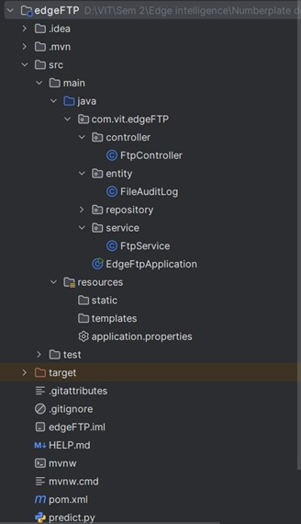
Figure 6: Spring Boot project structure — FtpController, FtpService, FileAuditLog entity

Step 3 — Service Layer (Business Logic)
The Service Layer handles all core operations. It first verifies that the FTP server and database connections are active, then performs the following:
- Generates metadata — unique filename and upload timestamp
- Resets the FTP working directory to the server root to avoid directory traversal errors
- Builds any missing folder structures on the FTP server recursively
- Uploads the image file to the correct remote path
- Triggers the ML detection model for number plate processing
- Saves the audit log to the PostgreSQL database

Step 4 — FTP Server (Smart Directory Management)
The uploaded image is stored on the centralized IIS FTP server. A key feature of the service layer is its smart directory management — before saving the file, it automatically checks whether the required folder structure exists on the FTP server. If any folder in the path is missing, it creates them recursively. This prevents upload failures caused by missing directories.
The FTP working directory is always reset to the root before path construction, which resolved a critical bug where nested directory navigation caused the client to lose its relative position.

Step 5 — ML Detection Model
After the image is stored, the detection model is triggered. It processes the image through the following pipeline:
- Loads the image from the FTP server
- Scans the image to identify the vehicle number plate region
- Draws a bounding box around the detected plate
- Generates an output image overlaid with the predicted bounding box and data labels
- Passes the cropped plate region to the OCR engine

Step 6 — OCR Engine (Text Extraction)
The OCR engine processes the detected number plate region and converts the characters into machine-readable text. Example output:
Detected Plate Text: KL07AB1234

Step 7 — Database Auditing (PostgreSQL)
Every successful file upload triggers the creation of a FileAuditLog entry in the PostgreSQL database. Hibernate (via Spring Data JPA) acts as the ORM layer, allowing the application to interact with the database using standard Java objects instead of raw SQL queries. The following data is stored for every upload:

Field | Description
file_name | Original name of the uploaded image file
remote_path | The path on the FTP server where the file was saved
upload_time | Precise timestamp of when the file was successfully uploaded

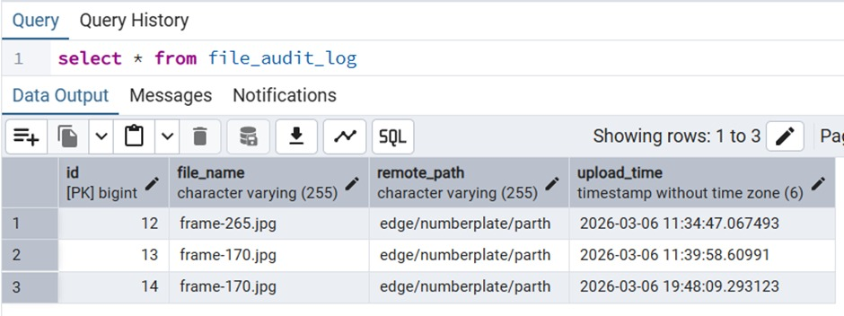
Figure 7: PostgreSQL file_audit_log table showing uploaded file records with timestamps
Hibernate automatically generates and executes the required SQL insert statement:
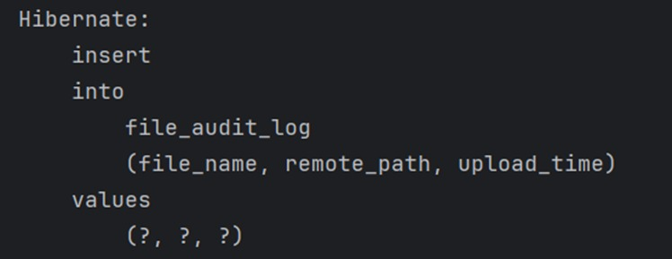
Figure 8: Hibernate-generated SQL insert statement for FileAuditLog

5. Core API Endpoints
The system exposes three primary REST API endpoints, all using custom HTTP headers to handle dynamic file paths:

5.1 Dynamic File Upload & Detection — POST /api/ftp/detect
This is the main endpoint. It accepts an image file and an X-Ftp-Path header to manage both FTP storage and ML model inference. Its key capabilities are:
- Smart Directory Management: Automatically and recursively builds any missing folder structures on the remote FTP server before saving the file.
- Integrated Model Processing: After upload, the image is fed into the ML detection model, which produces an output image with predicted bounding boxes and data labels overlaid.
- Audit Logging: On success, a FileAuditLog record is created in the database with filename, path, and timestamp.

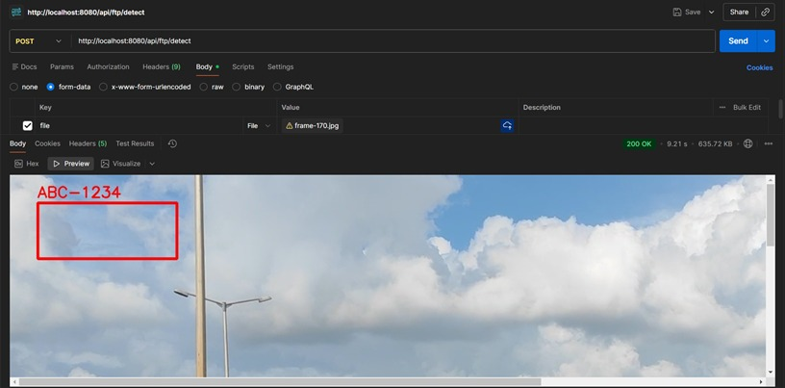
Figure 9: POST /api/ftp/detect — detection result showing bounding box with label ABC-1234
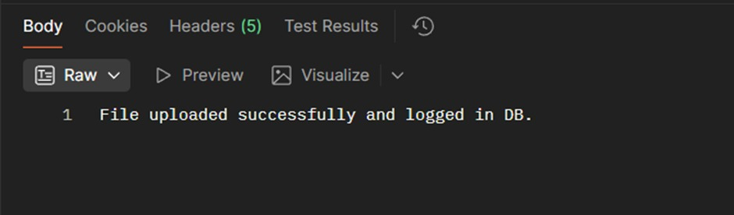
Figure 10: API success response confirming file upload and database log entry

5.2 Direct Image Retrieval — GET /api/ftp/download/image
This endpoint is designed for frontend asset loading. It uses the X-File-Path header to locate a specific file on the FTP server. The service streams the binary image data directly to the client, dynamically applying the correct HTTP Content-Type (image/jpeg or image/png) so the image renders inline in the browser.

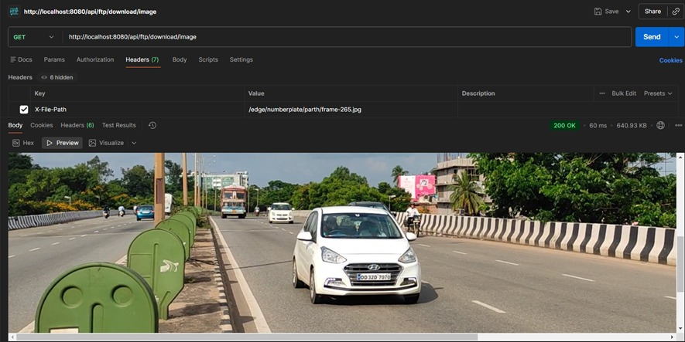
Figure 11: GET /api/ftp/download/image — retrieving and streaming an image from the FTP server

5.3 On-the-Fly Folder Archiving — GET /api/ftp/download/zip
This endpoint enables bulk data retrieval by packaging entire remote FTP directories into a single compressed archive. It iterates through all files in the target folder, streams them into a ZipOutputStream, and delivers a consolidated .zip file to the client — without requiring any intermediate local disk storage on the backend server.

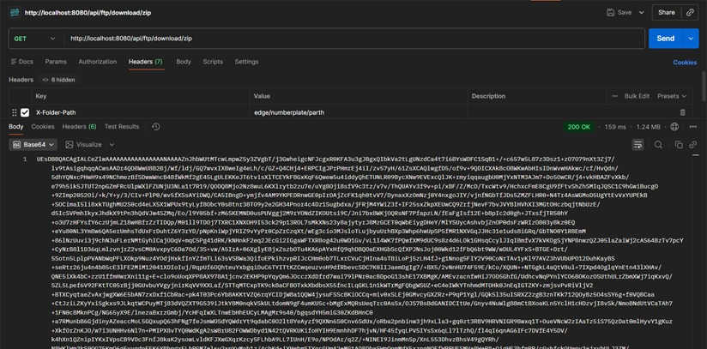
Figure 12: GET /api/ftp/download/zip — streaming a zipped archive of the FTP folder to the client
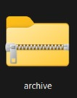
Figure 13: Downloaded .zip archive file

6. Technical Challenges and Resolutions

Challenge 1 — FTP Directory Traversal
A significant issue arose during development where standard FTP navigation logic caused the client to lose its relative position when uploading files into newly created, deeply nested directories. For example, after creating a folder two levels deep, subsequent FTP commands would fail because the working directory pointer was out of sync.
Resolution: A strict state-management protocol was implemented in the service layer. Before constructing any directory path, the working directory is explicitly reset to the FTP server root. The required folder structure is then built step by step from the root, ensuring consistent and reliable navigation at all times.

Challenge 2 — Windows IIS FTP Authentication
The IIS FTP server uses native Windows system accounts for authentication rather than its own internal user management. This caused access denial errors when the Spring Boot FTP client attempted to read and write files.
Resolution: A dedicated Windows local user account was created for the FTP service. An FTP Authorization Rule was configured in IIS Manager to grant this user explicit Read and Write permissions. Additionally, NTFS file system permissions on the physical storage directory were updated to give the user Full Control. These steps together resolved all authentication errors.

7. Deployment
The entire backend application is packaged as an executable JAR file, making it straightforward to deploy across different environments. To start the application, run:
java -jar number-plate-detection.jar
On startup, the following sequence occurs automatically:
- Spring Boot server initializes and loads all configurations
- Database connection to PostgreSQL is established; Hibernate auto-generates any missing tables
- FTP server connection is configured and verified
- All REST API endpoints become active and ready to receive requests

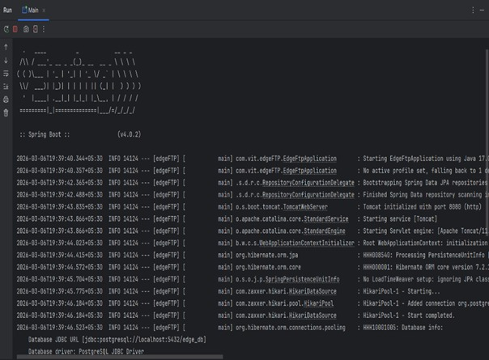
Figure 14: Spring Boot startup log showing successful server initialization and database connection

8. Key Technologies Used
Technology | Role in the System
Spring Boot (Java) | Backend framework; MVC architecture; REST API; dependency injection
Apache Commons Net (FTPClient) | Low-level FTP communication library for file uploads and directory management
Windows IIS FTP Server | Centralized FTP server running on Windows with Basic Authentication on port 21
ML Detection Model | Locates number plate region and overlays bounding box on output image
OCR Engine | Reads and converts plate characters to digital text
PostgreSQL | Relational database for storing audit logs and detection results
Hibernate ORM / Spring Data JPA | Object-relational mapper; auto-generates schema; removes need for raw SQL
JAR Package | Portable deployment format for the Spring Boot application

Conclusion
The finalized application serves as a highly scalable microservice that successfully bridges modern REST APIs with an FTP-based file storage system. By combining automated smart directory management, machine learning-based number plate detection, OCR text extraction, and persistent database auditing, the system provides a secure and reliable foundation for real-time vehicle number plate detection. The integration of Spring Boot, Apache Commons Net, Windows IIS FTP, PostgreSQL, and Hibernate ensures that the system operates efficiently and can scale to support multiple concurrent users without degradation in performance.

